# DEPARTMENT OF MECHANICAL ENGINEERING INDIAN INSTITUTE OF TECHNOLOGY (BHU) VARANASI – 221 005.

NOTICE:3060 Dated: 27/7/2021

**ATTENTION: *B.TECH PART-IV & INTEGRATED DUAL DEGREE PART-IV (VIIth Sem)***

Students are hereby informed that they are required to submit the **Project Topic** (**ME-392: UG Project-I)** with the consent of the Supervisor (Faculty Members) in the format given below latest by **Monday, 16th August 2021, 3:30 P.M**. to office mail i.e. (office.mec@itbhu.ac.in).



# (A.P.HARSHA) PROFESSOR & HEAD

Name Roll No.

1. Karymasetty Shimon Nabiel Martin 18135052
2. Kushagra Shukla 18135059

3. Amartya Das 18134023

4.

5.

Title of UG Project: "Application of Machine Learning in Fluid Mechanics"

Name of Supervisor : Dr. Anubhav Sinha

Signature of Supervisor

Name of Co-supervisor

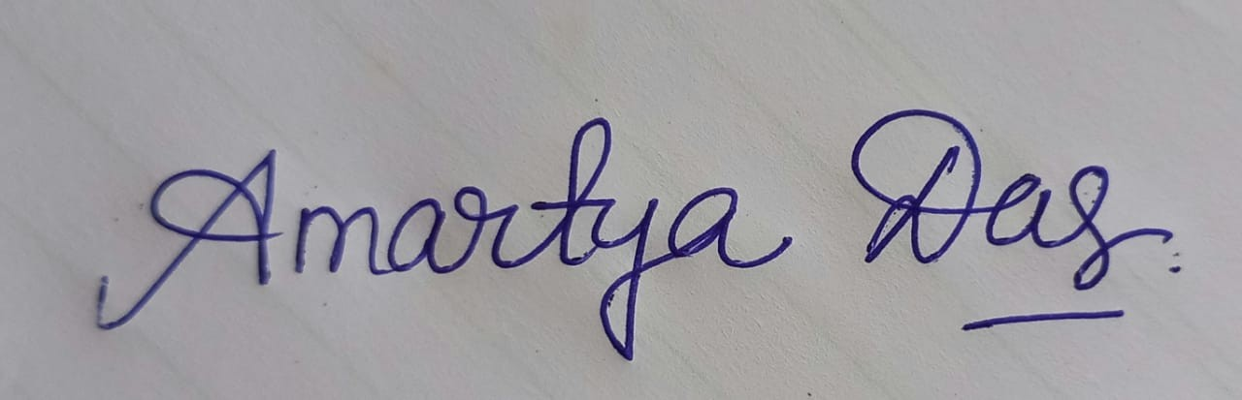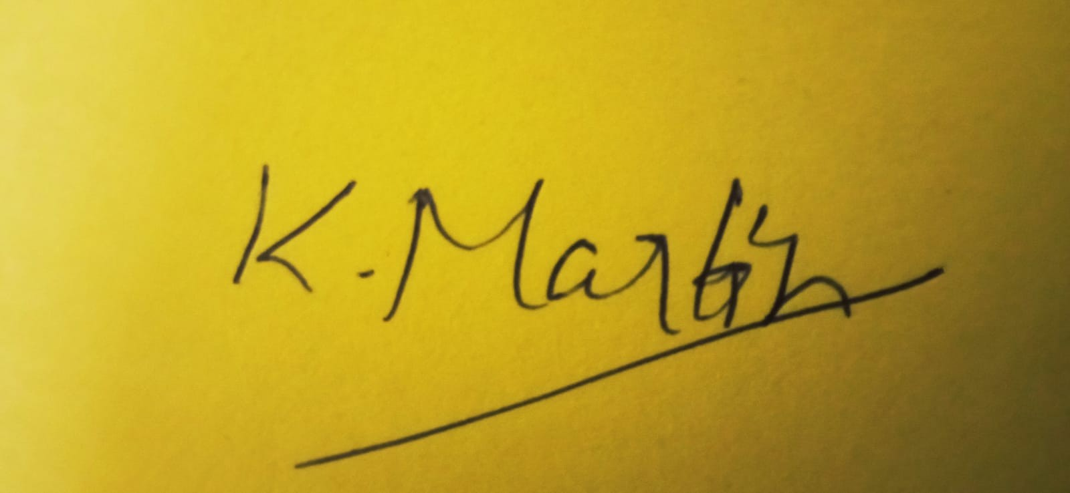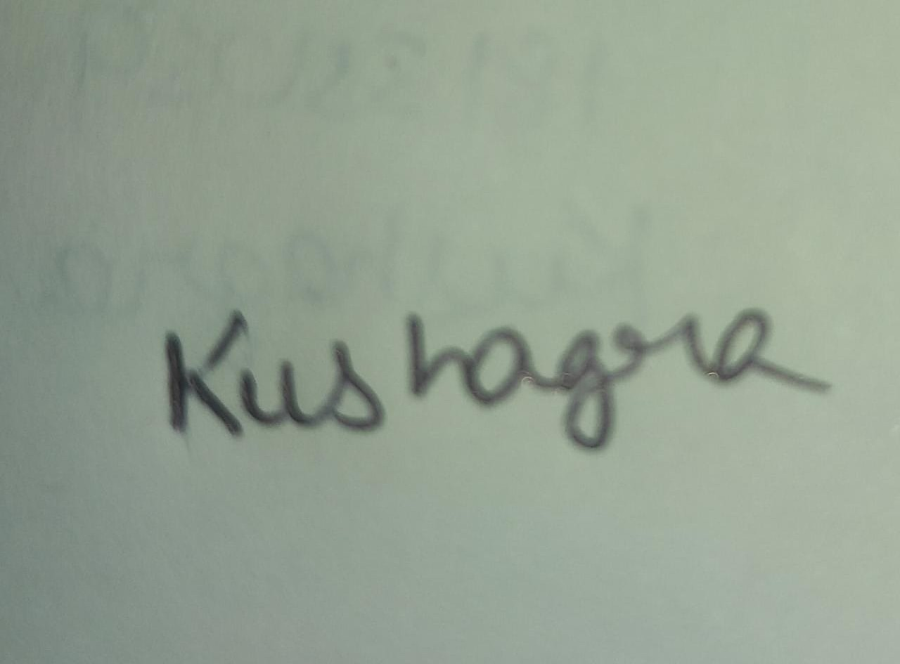

Signature of Co-supervisor Signature of Students

**Note**:

1 Number of students in a group should not be more than 5 for B.Tech./IDD.

2. * A teacher can supervise a maximum of 2 groups